**Key aggregate Screens**

Google App Engine Home page: Select keyaggregatecryptoapp link.

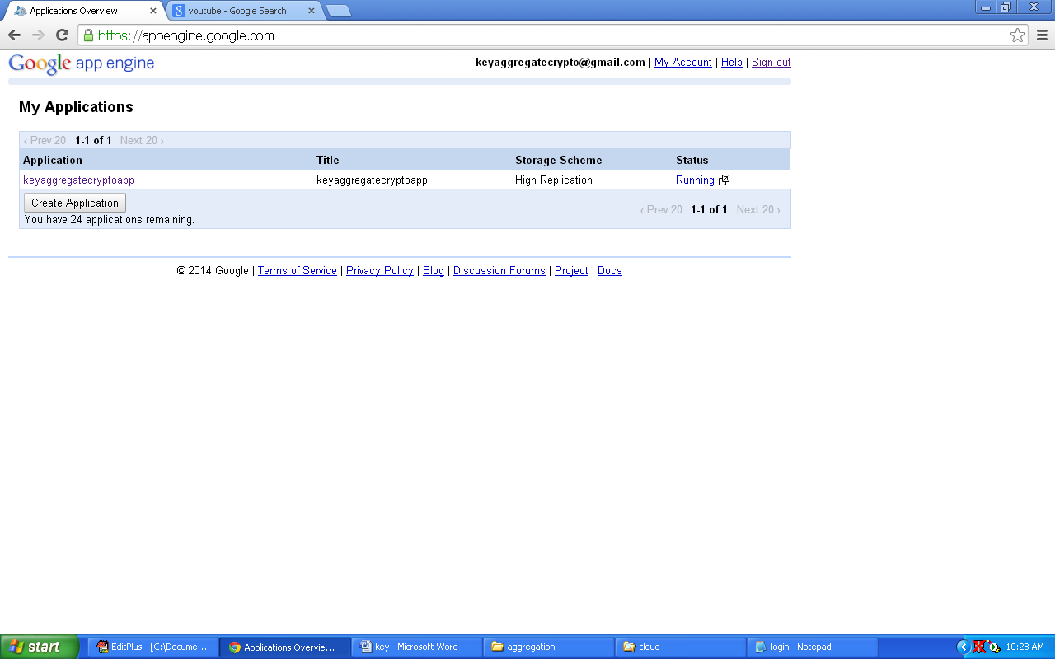

**Select Data store viewer:**

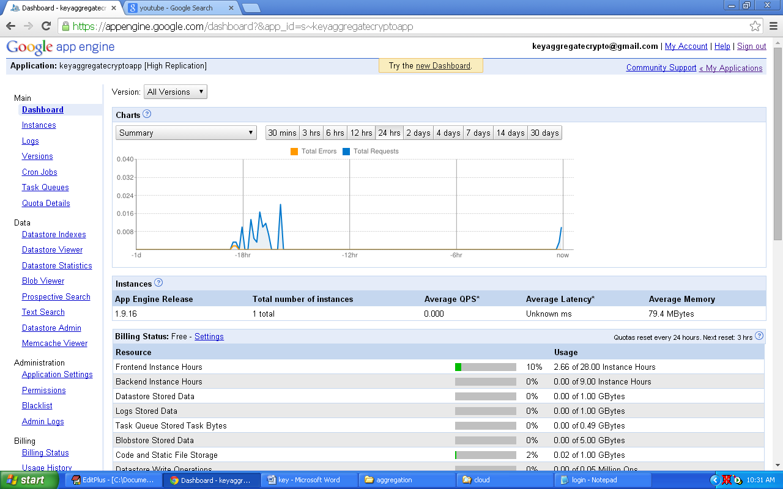

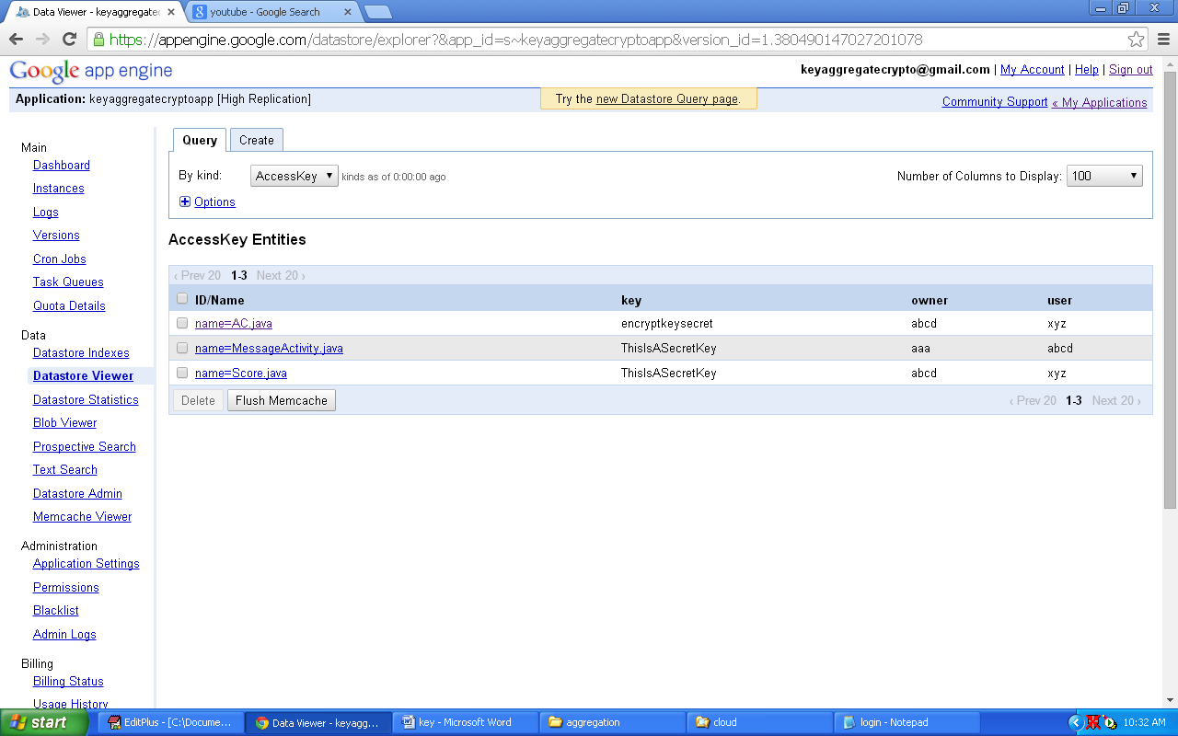

Create one folder in D directory. (Folder name as cloud)

Double click on Run.bat file in Aggregation folder (Code folder)

Click Register button to create new user.

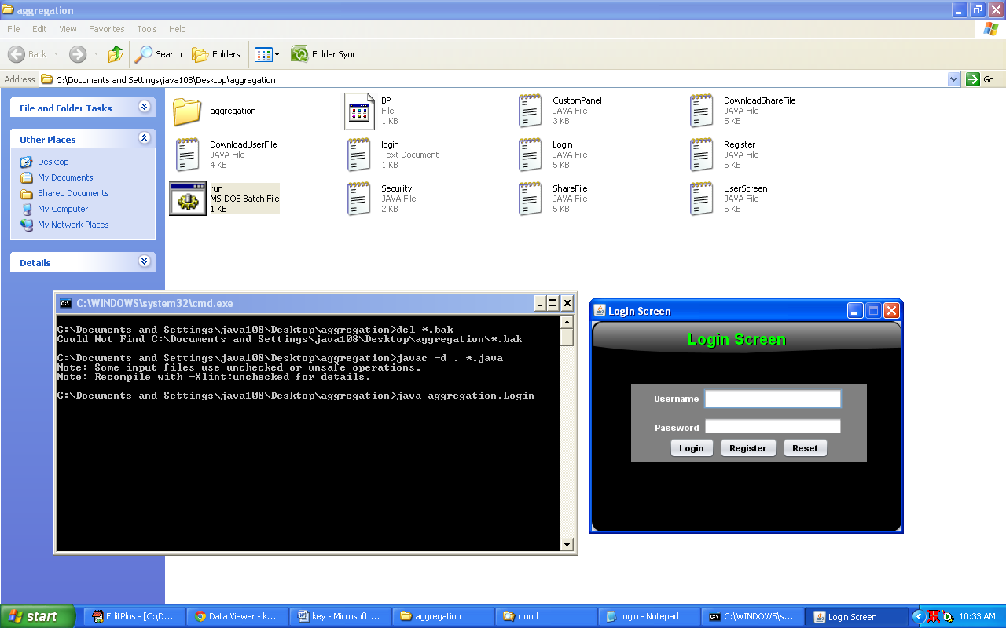

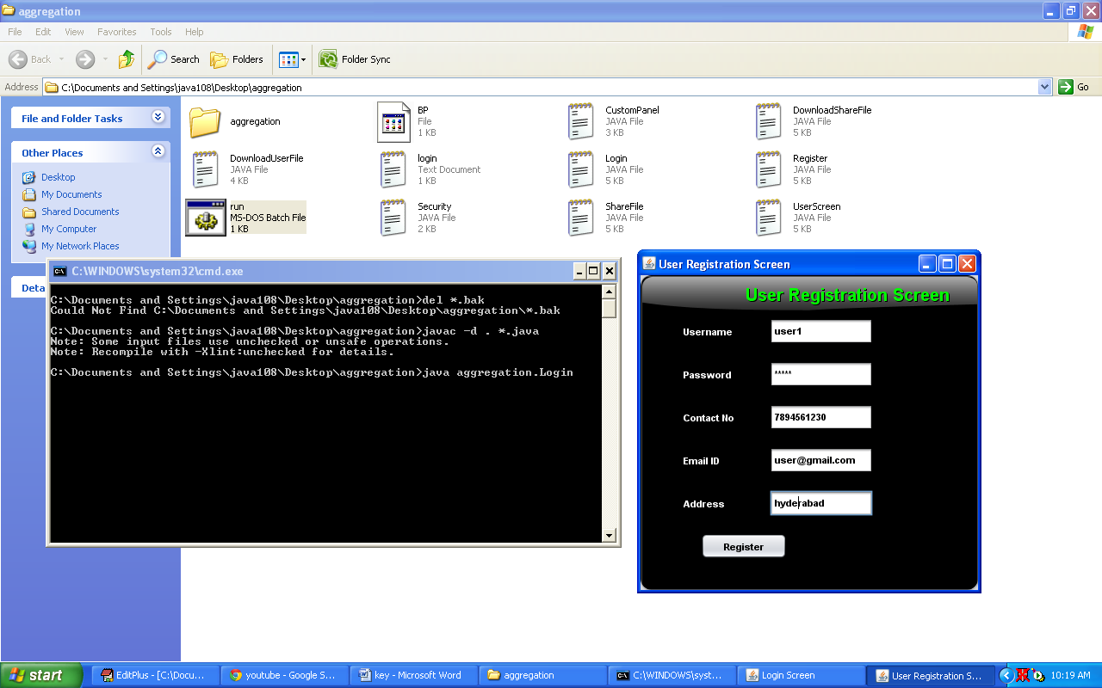

**Select AddUser option in datastore Viewer, it will shows list of data user details in cloud**

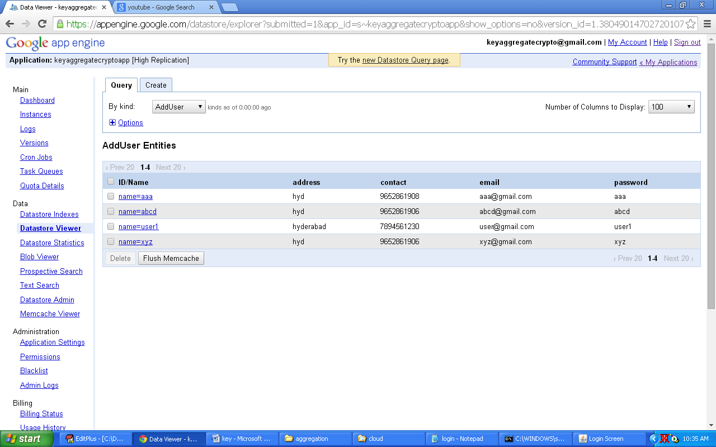

**Login user**

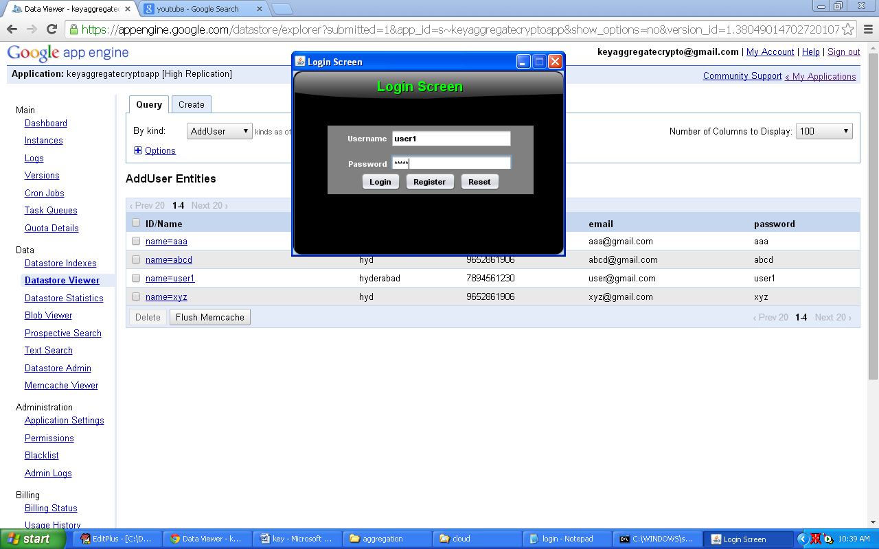

**After login user can upload files in to cloud.**

**Click upload button to upload files in to cloud**

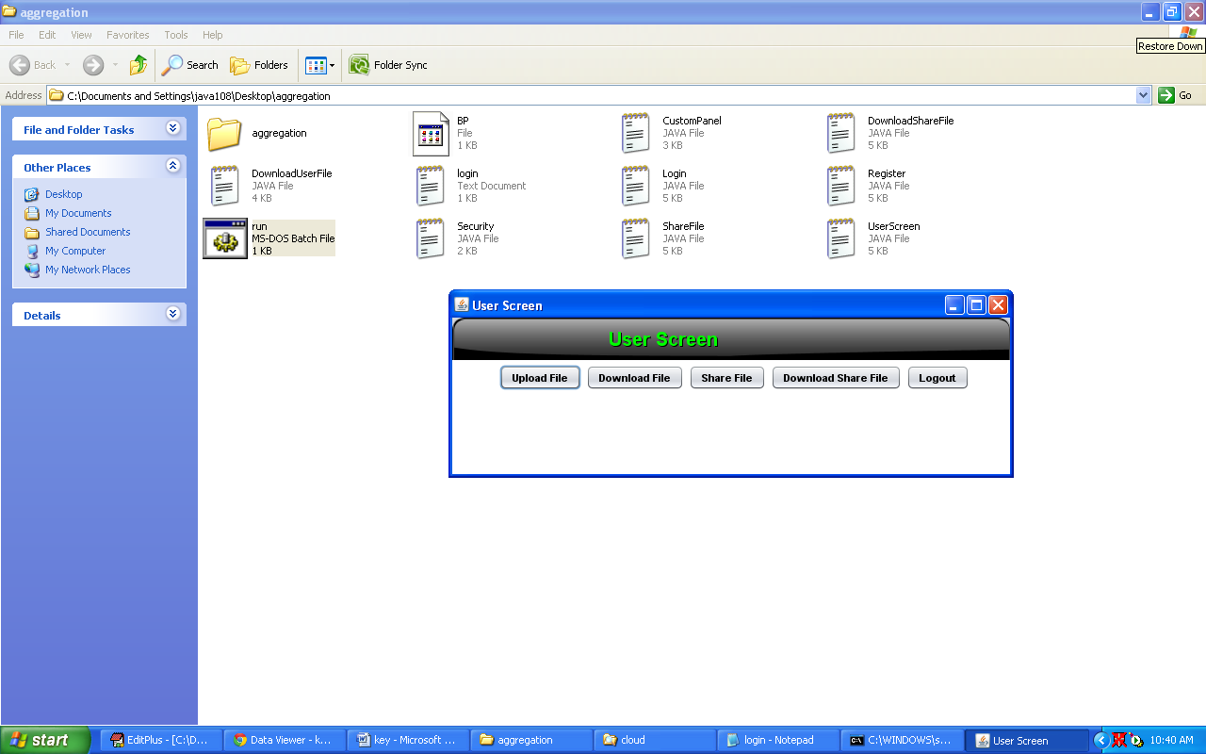

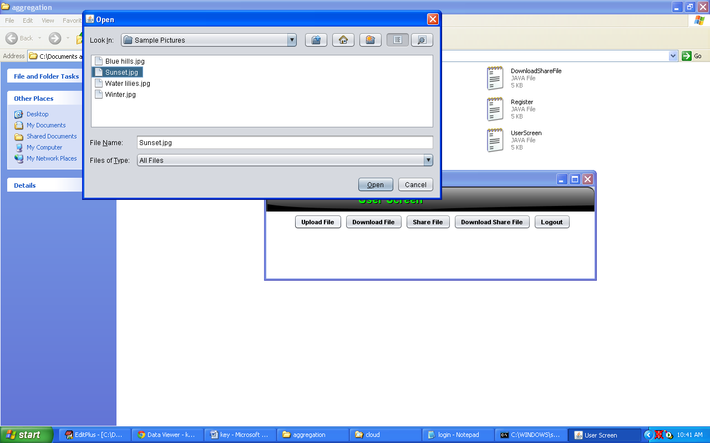

**After uploading the files, all files are stored in cloud folder in D Directory.**

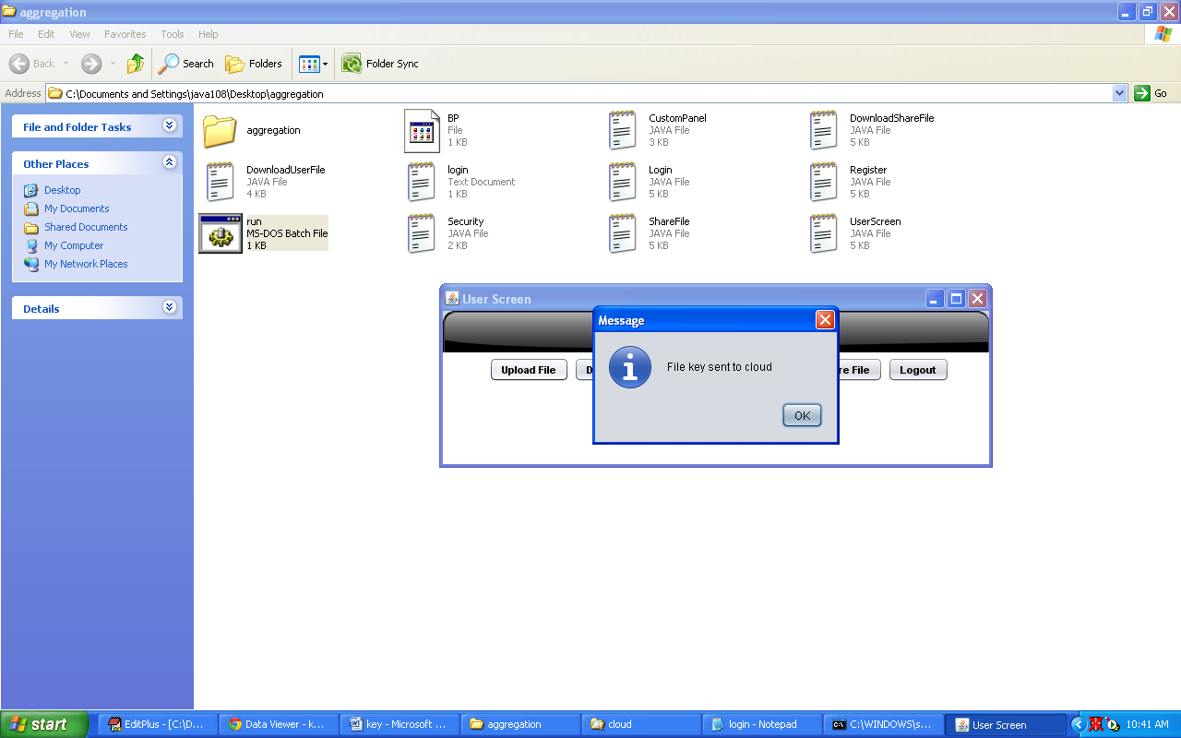

**Select FileKeys option to view the list of uploaded files with keys**

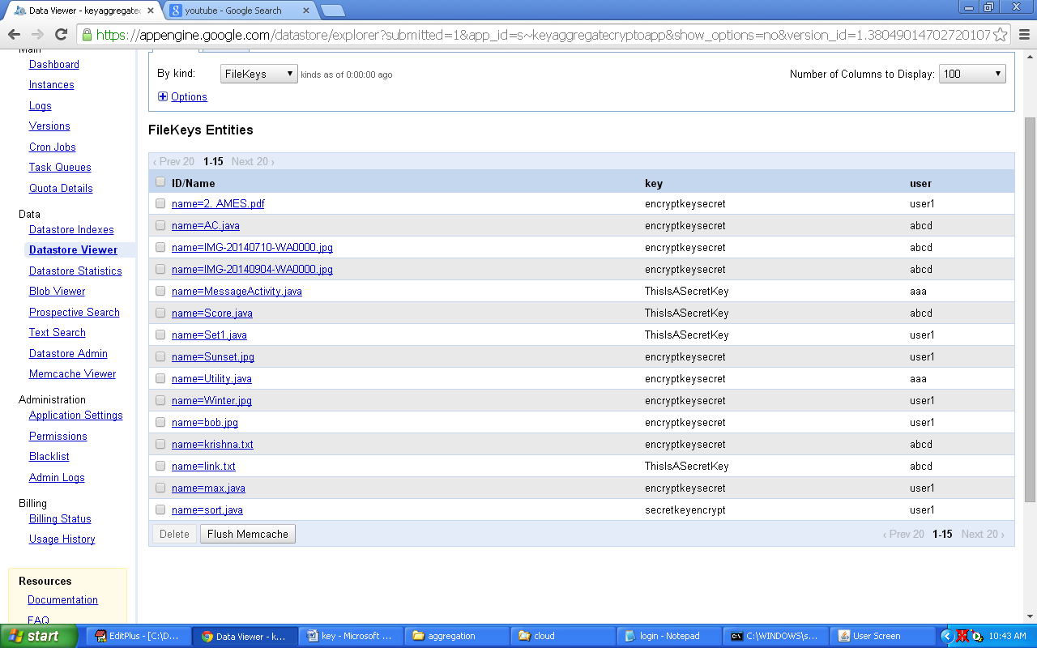

**Click on Download file Button. Here the user (user1) can download any file.**

**Select file name and click Download file button**

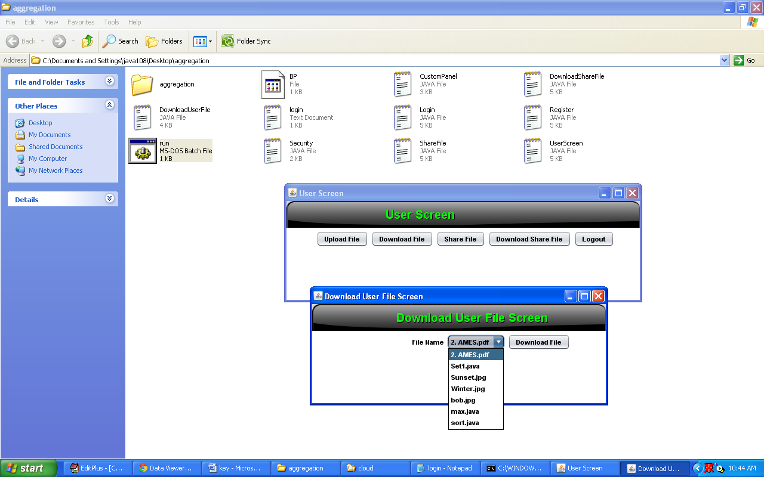

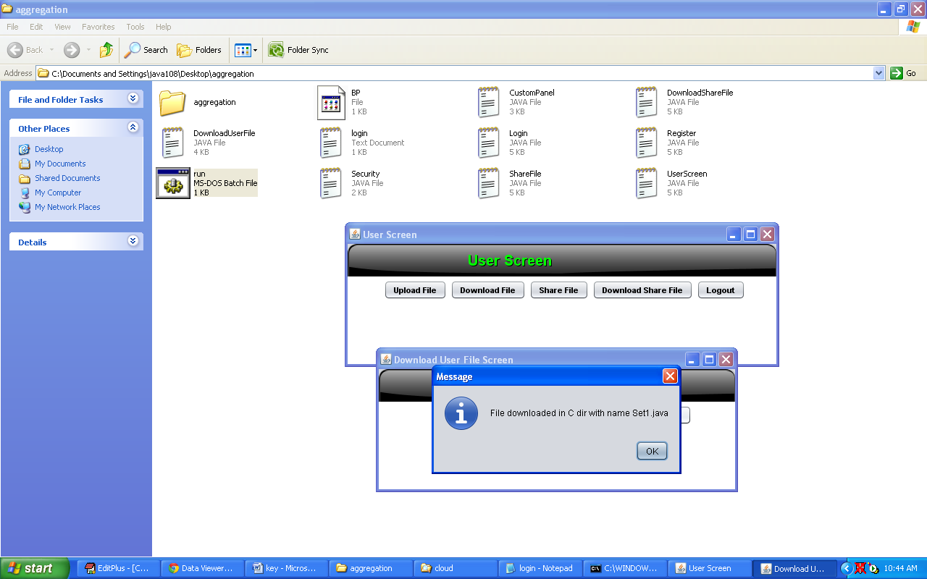

**Click share file button. Here user1 sharing some files to aaa (user)**

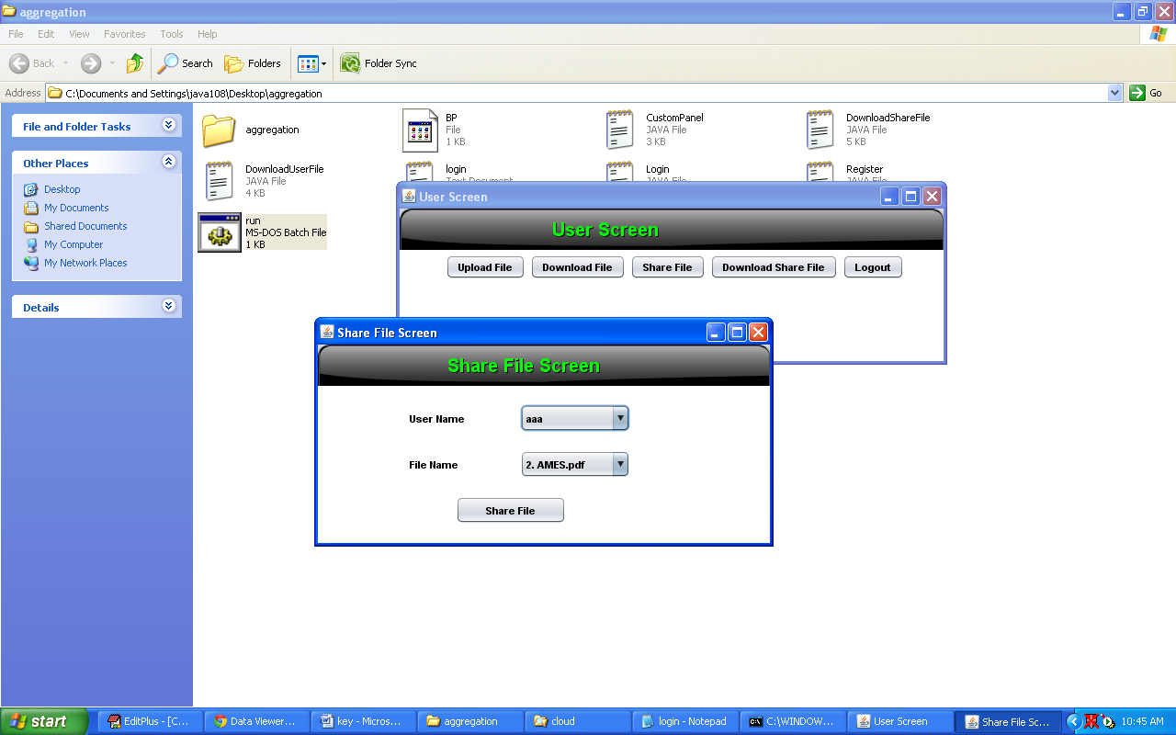

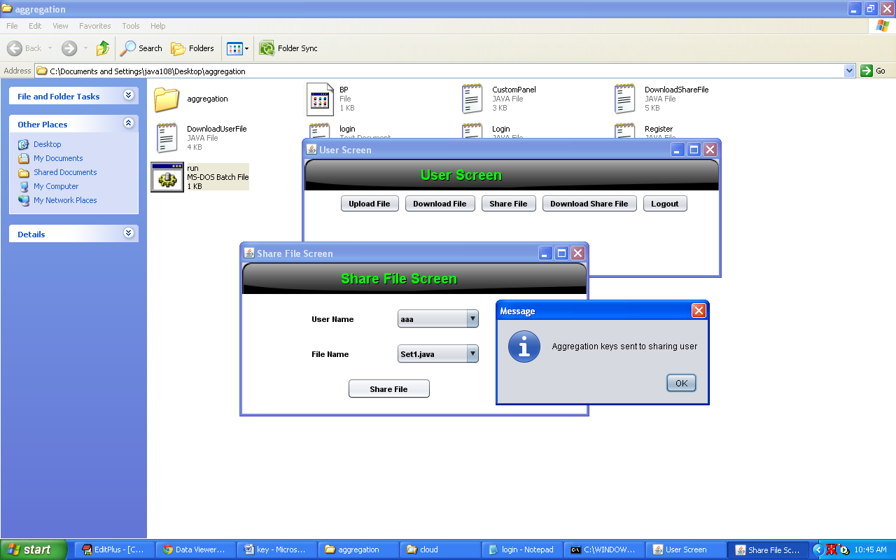

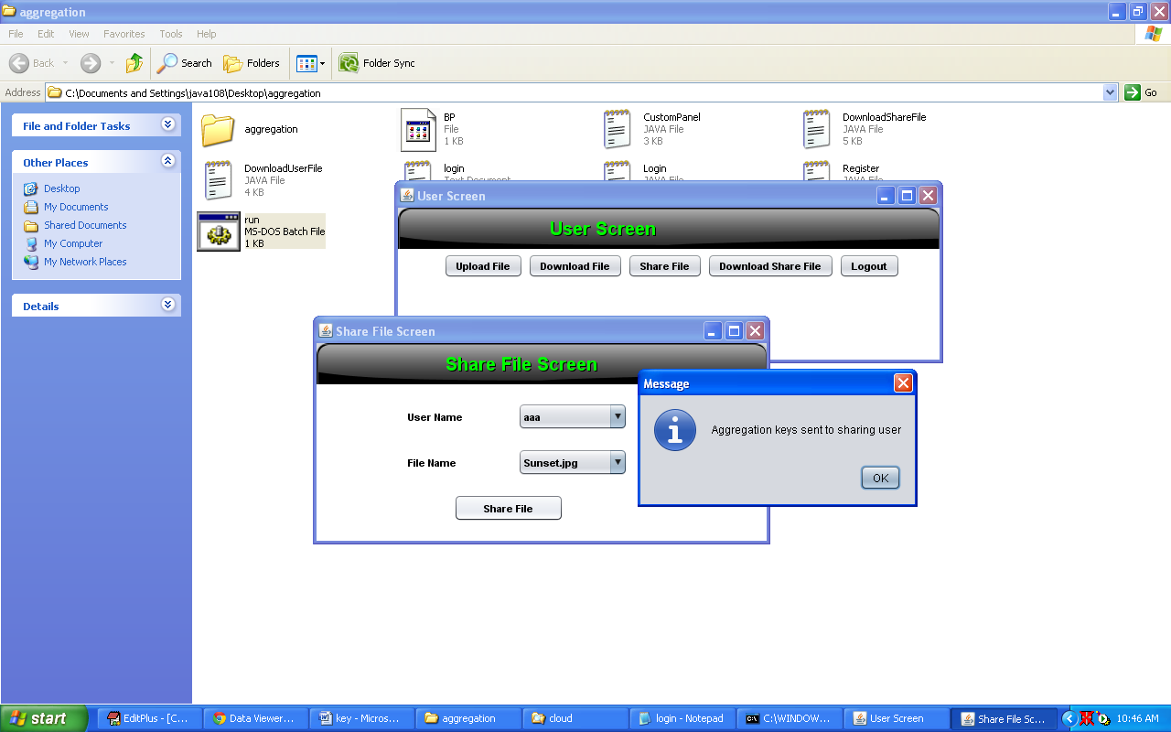

**User login (aaa)**

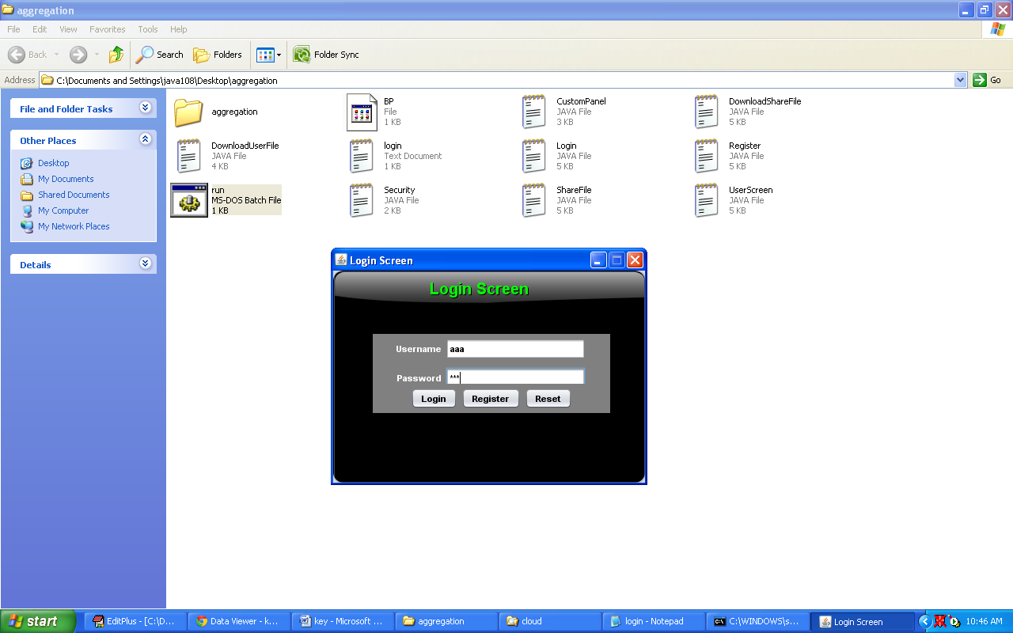

**Here aaa (user) can download only shared key files only**

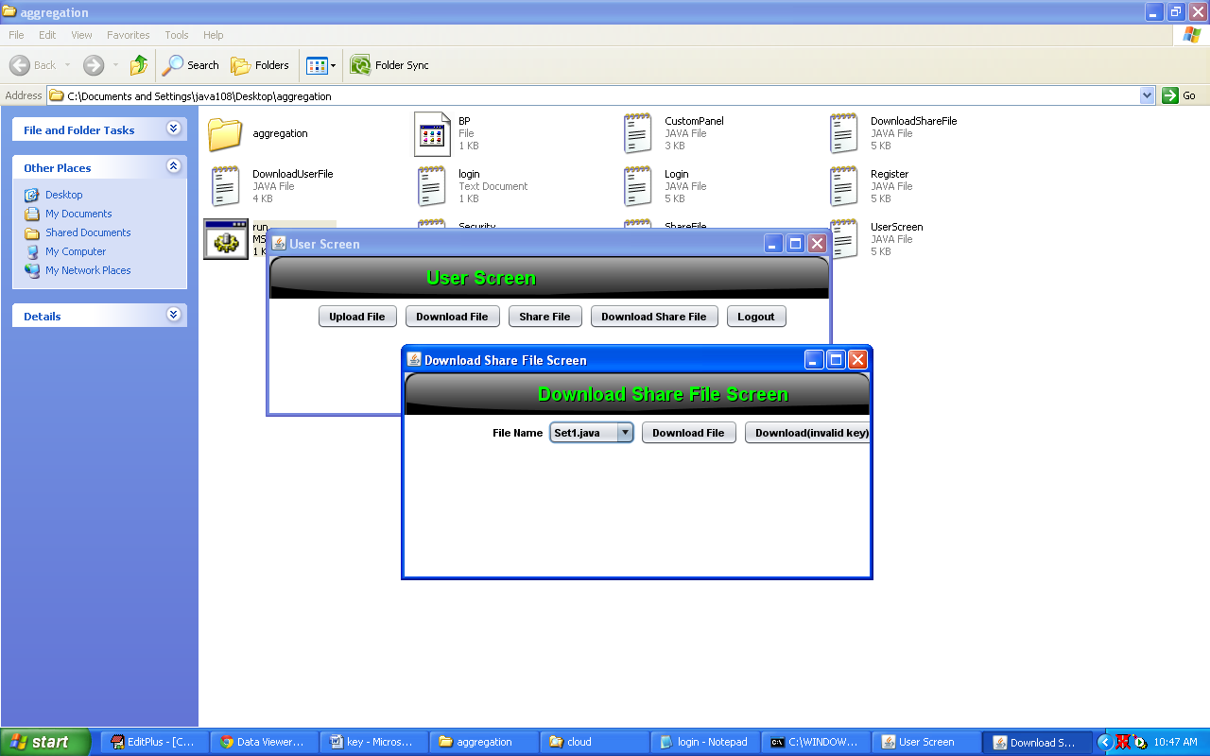

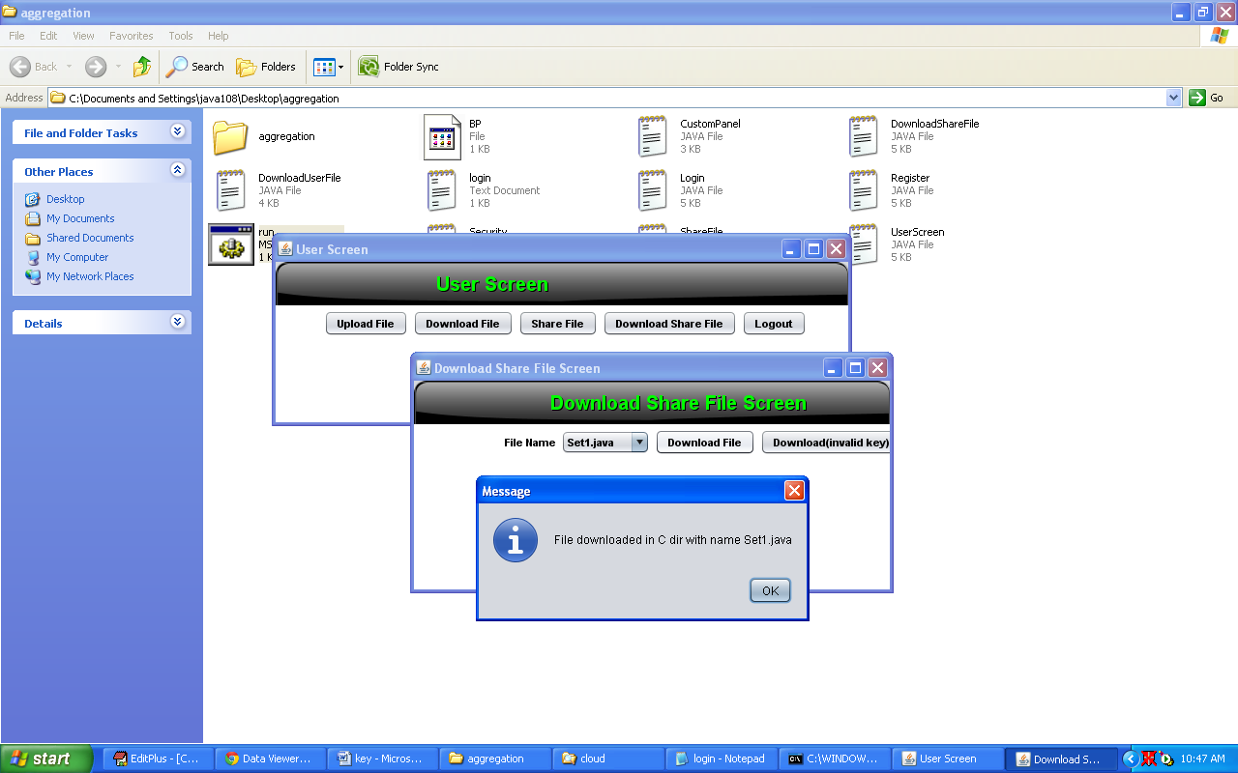

**Click on Download (invalid key) button. If you are trying to download with invalid key Exception will be occur.**

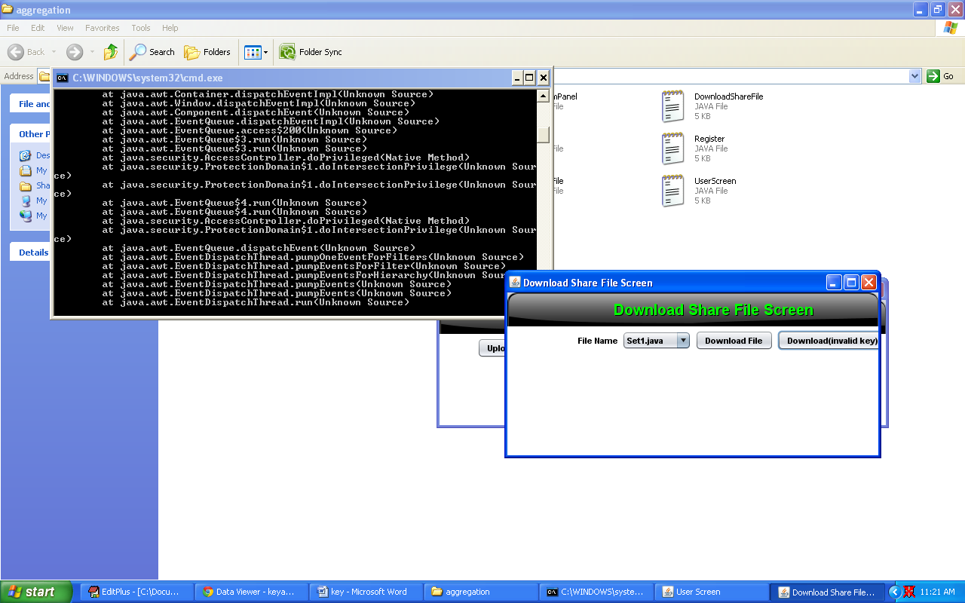

**All the user files are stored in cloud folder with encrypted format.**

